一、实验目的
本实验的目的是让学生巩固下列知识点。 ″ 子类的继承性。 ″ 子类对象的创建过程。 ″ 成员变量的继承与隐藏。 ″ 方法的继承与重写。
二、实验方案
编写程序模拟中国人、美国人是人，北京人是中国人。除主类外，程序中还有4个类： People、ChinaPeople、AmericanPeople 和 BeijingPeople 类。要求如下。 ″ People 类有权限是protected 的double型成员变量height 和weight，以及public void speakHello()、public void averageHeight()和 public void averageWeight()方法。 ″ ChinaPeople 类是 People 的子类，新增了 public void chinaGongfu()方法。要求 ChinaPeople 重写父类的 public void speakHello()、public void averageHeight()和 public void averageWeight()方法。 ″ AmericanPeople 类是 People 的子类，新增 public void americanBoxing()方法。要求 AmericanPeople 重写父类的 public void speakHello()、public void averageHeight()和 public void averageWeight()方法。 ″ BeijingPeople 类是 ChinaPeople 的子类，新增 public void beijingOpera()方法。要求 ChinaPeople 重写父类的 public void speakHello()、public void averageHeight()和 public void averageWeight()方法。
三、实验步骤
代码如下
一、People.java
package com.company;
public class People {
protected double weight;
protected double height;
public void speckHello() {
System.out.println("yayaya");
}
public void averageHeight() {
height = 173;
System.out.println("average height:" + height);
}
public void averggeWeight() {
weight = 70;
System.out.println("average weight:" + weight);
}
}
————————————————————————————————
二、ChinaPeople.java
package com.company;
public class ChinaPeople extends People {
public void speckHello(){
System.out.println("您好");
}
public void averageHeight(){
height=168.78;
System.out.println("中国人的平均身高:"+height+"厘米");
}
public void averggeWeight(){
weight=65;
System.out.println("中国人的平均体重:"+weight+"千克");
}
public void chinaGongfu(){
System.out.println("坐如钟，站如松，睡如弓！ ");
}
}
三、AmericanPeople
package com.company;
public class AmericanPeople extends People{
public void speckHello(){
System.out.println("How do you do");
}
public void averageHeight(){
height=176;
System.out.println("American&apos;s average height:"+height+"cm");
}
public void averggeWeight(){
weight=75;
System.out.println("American&apos;s average weight:"+weight+"kg");
}
public void americanBoxing(){
System.out.println("直拳，勾拳，组合拳！");
}
四、BeijingPeople.java
package com.company;
public class BeijingPeople extends ChinaPeople{
public void averageHeight(){
height=172.5;
System.out.println("北京人的平均身高:"+height+"厘米");
}
public void averggeWeight(){
weight=70;
System.out.println("北京人的平均体重:"+weight+"千克");
}
public void0 beijingOpera(){
System.out.println("花脸，青衣，花旦和老生！");}
五、Main.java
package com.company;
public class Main {
public static void main(String[] args) {
ChinaPeople chinapeople;
chinapeople = new ChinaPeople();
AmericanPeople americanpeople;
americanpeople = new AmericanPeople();
BeijingPeople beijingpeople;
beijingpeople = new BeijingPeople();
chinapeople.speckHello();
americanpeople.speckHello();
beijingpeople.speckHello();
chinapeople.averageHeight();
americanpeople.averageHeight();
beijingpeople.averageHeight();
chinapeople.averggeWeight();
americanpeople.averggeWeight();
beijingpeople.averggeWeight();
chinapeople.chinaGongfu();
americanpeople.americanBoxing();
beijingpeople.beijingOpera();
beijingpeople.chinaGongfu();
}
}
运行结果如下
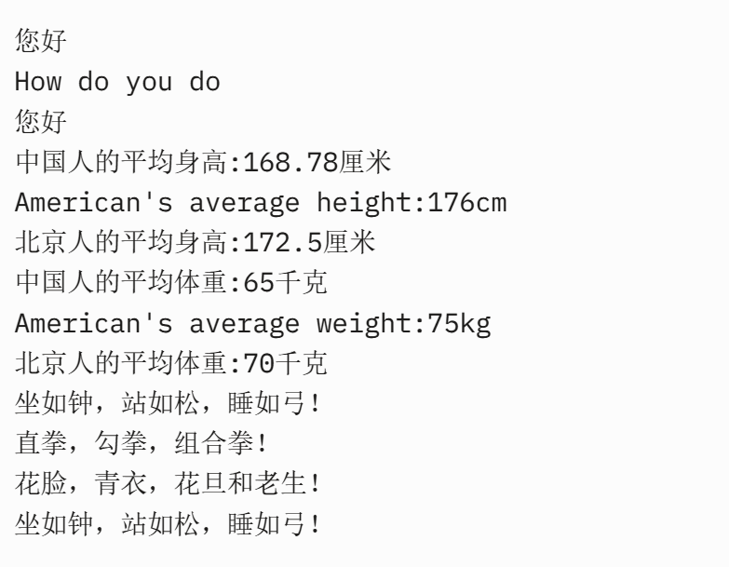

四、实验结果及分析
程序正确输出了要求的结果
五、实验总结及体会
学会了子类的继承性，子类对象的创建过程，成员变量的继承与隐藏，方法的继承与重写。

